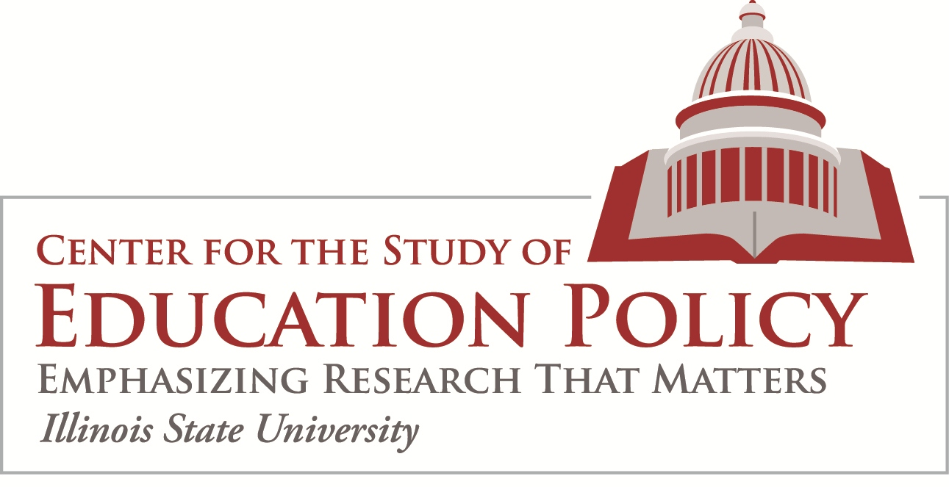

Summary of Constitutional Barriers to an Illinois School Voucher Program

Dr. Alicia Haller and Dr. Erika Hunt – February 2017

According to Private School Review, 284,245 students in Illinois attend private schools and there are 1,732 private schools located throughout the state. The vast majority of private schools in Illinois are religiously affiliated. Nationally, 12 states in the US have some form of voucher program that provides public funds for students whose parents choose to send them to private schools. Currently, there are no laws or regulations barring the Illinois General Assembly, Illinois State Board of Education, or any county, city, town, or district from establishing a voucher program that would fund tuition to non-religious institutions. However, there are substantial state constitutional barriers for providing vouchers to religiously affiliated schools in Illinois.
In the 1980s, the U.S. Supreme Court ruled that a state program to reimburse low-income parents for parochial school tuition violated the Establishment Clause of the First Amendment, which prohibits government from advancing any religion. The Illinois Supreme Court had previously struck down a tuition voucher program for parents for similar reasons. In both cases, it made no difference that government funds went to the parents/students rather than the religious school. The courts deemed those voucher programs unconstitutional because they provided an overly-broad level of financial support for religious institutions.

In 2002, revisiting the constitutionality of voucher programs, the U.S. Supreme Court upheld a lower court ruling on Ohio’s Cleveland Scholarship Program (Zelman v. Simmons-Harris, 536 U.S. 639). In that case, the court found that the program was narrow enough in scope to be allowable under the US Constitution. Through Zelman, the U.S. Supreme Court established that voucher programs that provide public funding to religious schools do not violate the Establishment Clause, so long as such education program is religiously neutral and based on true private choice. Zelman sets the standards that all school choice programs must meet to comply with the First Amendment’s Establishment Clause. In fact, policy makers in Milwaukee, Washington D.C., and others have relied on the federal Zelman v. Simmons-Harris ruling in the design and/or revision of their voucher programs.

However, the US Supreme Court ruling is not the only consideration for the establishment of a legal voucher program in Illinois. Regardless of whether or not a school removes the religious education component from their program, publicly-funded tuition vouchers/scholarship programs have been determined by Illinois courts to ultimately support the religious organizations in which they operate. Therefore, even though the U.S. Supreme Court allows for a more nuanced interpretation of the Establishment Clause regarding public funding for religiously affiliated schools, a school voucher program in Illinois could still run afoul of clear language in Articles I § 3 and X § 3 of Illinois Constitution, which provide:

ARTICLE I – Section 3 - The Compelled Support Clause, states “No person shall be required to attend or support any ministry or place of worship against his consent…”

ARTICLE X - Section 3 - the Blaine Amendment, states “PUBLIC FUNDS FOR SECTARIAN PURPOSE FORBIDDEN Neither the General Assembly nor any county, city, town, township, school district, or other public corporation, shall ever make any appropriation or pay from any public fund whatever, anything in aid of any church or sectarian purpose, or to help support or sustain any school, academy, seminary, college, university, or other literary or scientific institution, controlled by any church or sectarian denomination whatever; nor shall any grant or donation of land, money, or other personal property ever be made by the State, or any such public corporation, to any church, or for any sectarian purpose.”
An argument could be made that Article I, Section 3 implies that voucher programs are unconstitutional because no taxpayers can be compelled to have their tax dollars used to support a religious institution. But that rather vague language alone was likely not sufficient to determine a ruling, as interpretations of what constitutes “support” or “consent” could vary greatly. The combination of Article I, Section 3 along with Article X, Section 3 formed the basis for the Illinois Supreme Court’s decision to bar only unrestricted public funds from allocation to religious schools in Illinois. Restricted vs. unrestricted funding was an important distinction drawn by the Court, because there was some precedent for funds being allocated to religious schools in Illinois. For example, the Illinois Supreme Court has only found that unrestricted payments of public funds to religious schools in the form of tuition vouchers/scholarships are unconstitutional, asserting that those funds ultimately serve to benefit the religious institution as a whole. Due to the unrestricted nature of tuition, it actually serves to subsidize costs for the operation of the religious organization (e.g. tuition dollars are used to support facilities, maintenance, operational costs, administration, etc. that cannot be considered exclusive to the use of the secular or academic school component). In other words, even if a religious school eliminates the religious education component, public funding in the form of tuition vouchers would still be viewed as supporting the religious organization.

The unrestricted nature of tuition is very different from statutes that provided restricted funds for the transportation of private school students at public expense and the use of public funds to pay for textbooks and nursing services provided in religious schools. The understanding that only unrestricted public funds are barred from allocation to religious institutions was reinforced by the courts in other decisions involving tuition tax credits. Recently, two Illinois teachers’ unions separately challenged the constitutionality of an Illinois tax credit program for tuition to private schools and/or out-of-district public schools. Two trial courts and Illinois Courts of Appeal upheld the tax credit program, citing it constitutional under both the federal Establishment Clause and the Illinois Constitution’s Religion Clause. Further, the Illinois Supreme Court denied appeals on those rulings. (Toney v. Bower, 2001; and Griffith v. Bower, 2001).

Therefore, the State of Illinois has only provided restricted funds to support student in religious schools. Those funds have been targeted toward very specific allowable goods and services, that are secular in nature and do not support the religious organization overall (e.g. secular text books, transportation, special education accommodations, tax credit for tuition, etc.).

Illinois Governor, Bruce Rauner, has publicly supported reform efforts aimed at school choice. Stressing the need to provide equitable educational opportunities for all student throughout Illinois, in 2016 the Governor created the Illinois School Funding Reform Commission. The bipartisan/bicameral Commission was charged with developing an equitable school funding system for the state. It is important to note that the Commission’s final report, released in 2017, contains no reference to tuition vouchers. In fact, the only reference to school choice is listed under the heading “Outstanding Issues Requiring Resolution.” It states “Governor Rauner and some members of the Commission support the availability of school choice tax credits for individuals or corporations donating money to fund scholarships for low-income students, as long as those schools are nonprofit and the accepting school publishes accountability data equivalent to what is required for public schools.” It is unclear from the Commission’s report what the anticipated revenue loss would be from the envisioned tax exemption involved, or what the impact would be to state funding for education in Illinois.

OTHER RELEVANT ILLINOIS CASE LAW
Board of Education v. Bakalis (Ill. 1973) An Illinois Supreme Court case involving a statute requiring public school buses to transport private school students. The court ruled that the statute did not violate Article X § 3 of the Illinois constitution because the statute was intended and implemented as a health-and-safety measure that benefited all students.

People ex rel. Klinger v. Howlett, (Ill. 1973) The Illinois Supreme Court case involving tuition vouchers/grants to religious schools. The court ruled that unrestricted public funds provided to religious organizations could ultimately subsidize religious services. Such subsidization would violate Article X § 3 of the Illinois Constitution. Therefore the program was found unconstitutional. However, the court opened the door for restricted, targeted funding that did not support the religious organization. In fact, the court determined that the state should not treat private school students differently than public school students with respect to such things as secular textbooks, nursing services, etc.

MECHANISMS TO CHANGE THE ILLINOIS CONSTITUTION
There are currently only three ways in which the Illinois Constitution can be amended/modified:
- by a constitutional convention with changes submitted to the voters,
- by amendments approved by the General Assembly and submitted to the voters, or
- by petition initiated by the people limited to the structure and procedures of the Legislature and submitted to the voters.
Regardless of how an amendment is proposed, the issue must be placed on the ballot of a statewide election and passage requires that a supermajority of voters must agree to the change. Additionally, a limit of no more than three amendments can be put to the voters per general election. The Illinois Constitution has been successfully amended 14 times since 1970.

